Polling District and Polling Station Review
Statutory public consultation 16.10.23 to 13.11.23
Partner information pack
Introduction
North Yorkshire Council are required to carry out a consultation with North Yorkshire residents and stakeholders about the council's proposal for the polling districts and location of polling stations in every parliamentary constituency in North Yorkshire.
There are 888 polling districts under review.
We want to seek the views of the public on the proposals and, in particular, engage with seldom heard groups who have specific needs and may find it difficult to travel to/ access their local polling station. We also want to hear the views of elected representatives – NYC members, MPs and parish councils.
What is the ask of you?
North Yorkshire Council wants to encourage as many people as possible to take part in this consultation – and we need your help!
You are receiving this pack as the representative of an organisation who we hope may be able to help us engage with your audiences. In this pack you will find any overview of the public campaign, and assets to help you promote it.
Please help us by sharing with your networks, groups, and contacts. This pack is designed to help by providing content for you to share if possible – in it you will find wording to copy and paste, and images to use on social media.
The survey is also available as a paper copy and other accessible formats and languages can be requested.
Please email elections@northyorks.gov.uk to do so.

What is the call to action for the public?
We are asking residents to view our proposals and give their views on them via an online survey available at www.northyorks.gov.uk/PollingPlacesReview or by completing a paper copy (available on request). Responses will be shared with the council’s elected members in December before the register of polling places is republished in February 2024.
Stakeholder engagement
We would also like other key stakeholders such as parish councils, community organisations and other elected officials to give their views using the same survey.

How residents can take part
The consultation goes live on Monday 16 October and runs for four weeks until Monday 13 November. As well as working with you, our trusted partners, we will be issuing a press release and advertising the consultation through our social media channels, website and email newsletter.
There are several ways residents can take part in this consultation
Online
The online survey is hosted on the North Yorkshire Council website. The link to access it is www.northyorks.gov.uk/PollingPlacesReview
Paper Copy
A paper copy can be requested from the council’s elections team.
Residents and our partners can do so by emailing elections@northyorks.gov.uk or calling the customer service centre on 0300 131 2131 and say Polling District Review when prompted.
Accessible formats of the survey are also available on request using the contact details above.
How can you help?
Learnings from previous campaigns show that by using trusted channels and voices to communicate with residents, we get the best rates of response.
Therefore, we are asking you to help us by engaging with your networks and the audiences that you serve and encouraging them to complete the survey.

Polling District and Station Review Consultation – Communications Pack
To help with this, we have developed a few resources for you to use if possible.
This pack contains information on:
- Key Messages
- Example words to use in a newsletter or on websites or in correspondence
- Example words to use in social media (Facebook, Twitter and Instagram) and images
- How to request paper surveys.

Key messages
- We are conducting a review of our polling districts and polling stations.
- We want to hear about your experiences of voting in North Yorkshire
- We want to hear your views of these proposals.
- We are particularly interested in hearing from you if you find it challenging to travel to and/or access your local polling station.
- Feedback will be shared with councillors to help shape voting in North Yorkshire.

Example words for use in email /newsletter / to share with your networks and communities

• For use from Monday 16 October to Monday 13 November 2023.
Please share your experiences with North Yorkshire Council to help shape the future of voting in North Yorkshire
North Yorkshire Council is conducting a review of its polling districts and polling stations.
We have made draft recommendations for polling stations in each area.
There are 888 proposed voting locations across North Yorkshire to be used for voting during elections.
We are asking for your views on our proposals between Monday 16 October and Monday 13 November and are particularly interested in hearing from you if you find it challenging to travel to and/or access your local polling station.
The proposed polling districts and designated polling stations can be viewed at www.northyorks.gov.uk/PollingPlacesReview.
This consultation will help the council understand your experience of using polling stations in your area and the feedback you give will be shared with our councillors.
Please fill in the survey here www.northyorks.gov.uk/consultations no later than Monday 13 November. You can also request a paper survey other accessible formats by emailing elections@northyorks.gov.uk or ringing 0300 131 2131 and say ‘Polling District Consultation’ when prompted.
Please share your experiences with the council to help shape the future of voting in North Yorkshire, and tell your colleagues, friends, and family to do the same!

Example words to help publicise the survey on your channels

Social media assets
Below you will find some ideas for messages and image assets - please use these where possible to inform your audiences about this campaign.
We will be posting/tweeting about this across NYC social media accounts, which you could also share if appropriate. Please check @northyorksc for the latest content.
Suggested social media messages for use on your channels:For use from Monday 16 October to Monday 13 November 2023.
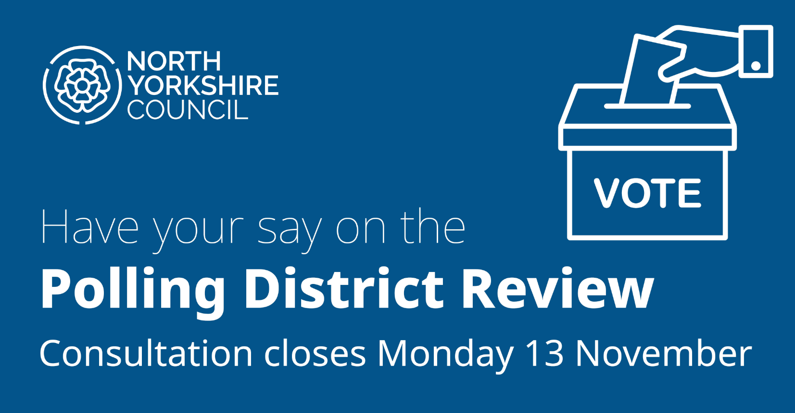 | Facebook version  North Yorkshire Council is conducting a review of polling districts and polling places.  They are seeking feedback on their recommendations and are particularly interested in hearing from you if you find it challenging to travel to and/or access your local polling station.  The consultation is now live and will close on 13 November 2023.  Find out more and share your thoughts here: www.northyorks.gov.uk/PollingPlacesReview
Twitter version
North Yorkshire Council is reviewing its polling districts.
They are seeking feedback on their recommendations and are particularly interested in hearing from you if you find it challenging to access your local polling station.
Find out more here: www.northyorks.gov.uk/PollingPlacesReview
Instagram version
North Yorkshire Council is conducting a review of polling districts and polling places.
They are seeking feedback on their recommendations and are particularly interested in hearing from you if you find it challenging to travel to and/or access your local polling station.
The consultation is now live and will close on 13 November 2023.
Find out more and share your thoughts here: www.northyorks.gov.uk/PollingPlacesReview

Thank you for your help with promoting this campaign among your networks and helping us to engage with your audiences

