NOTICE OF ELECTION |  |  | 
Election of | County Councillors
To | North Yorkshire County Council
Scheduled for | 05 May 2022
For divisions within the borough area of | Harrogate |  |  | 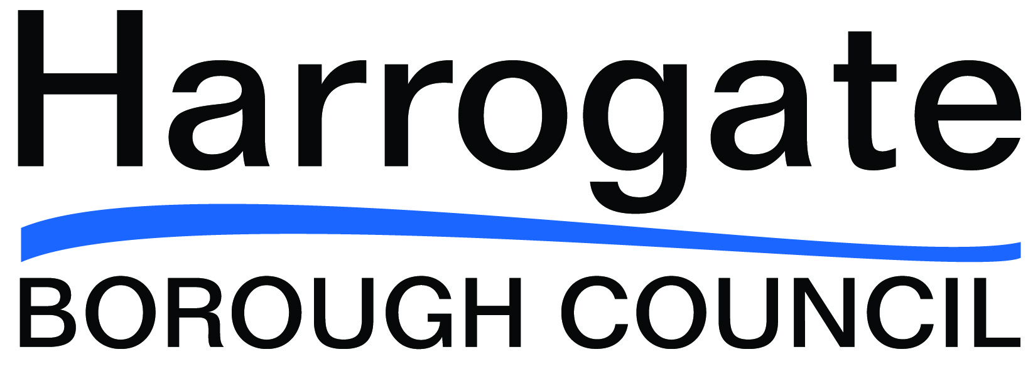
Division | Seats | Division |  |  | Seats
Bilton & Nidd Gorge | 1 | Oatlands & Pannal |  |  | 1
Bilton Grange & New Park | 1 | Ouseburn |  |  | 1
Boroughbridge & Claro | 1 | Pateley Bridge & Nidderdale |  |  | 1
Coppice Valley & Duchy | 1 | Ripon Minster & Moorside |  |  | 1
Fairfax & Starbeck | 1 | Ripon Ure Bank & Spa |  |  | 1
Harlow & St Georges | 1 | Spofforth with Lower Wharfedale & Tockwith |  |  | 1
High Harrogate & Kingsley | 1 | Stray, Woodlands & Hookstone |  |  | 1
Killinghall, Hampsthwaite & Saltergate | 1 | Valley Gardens & Central Harrogate |  |  | 1
Knaresborough East | 1 | Washburn & Birstwith |  |  | 1
Knaresborough West | 1 | Wathvale & Bishop Monkton |  |  | 1
Masham & Fountains | 1

- Nomination papers must be delivered BY HAND to the office of the Deputy Returning Officer on any working day after the date of this notice between the hours of 10 am and 4 pm but not later than 4pm on Tuesday, 5th April 2022.
- Nomination papers can be obtained from the Deputy Returning Officer (address below), during the times stated above, or from the Harrogate Borough Council website.
- If the election is contested, the poll will take place on Thursday, 5th May 2022.
- Applications to register to vote must reach the Electoral Registration Officer by 12 midnight on Thursday, 14th April 2022. Applications can be made online: https://www.gov.uk/register-to-vote.
- Applications, amendments or cancellations of postal votes must reach the Electoral Registration Officer (address below) by 5pm on Tuesday, 19th April 2022.
- Applications to vote by proxy at this election must reach the Electoral Registration Officer (address below) by 5pm on Tuesday, 26th April 2022.
- Applications to vote by emergency proxy at this election must reach the Electoral Registration Officer (address below) by 5pm on Thursday, 5th May 2022.

Dated: Friday, 18th March 2022 Wallace Sampson
Deputy Returning Officer
Civic Centre
St Lukes Avenue
Harrogate
HG1 2AE
(Printed and Published by Harrogate Borough Council)

